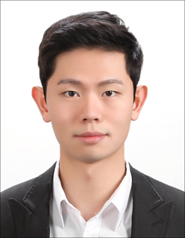
Se-hyeok Jang
1 Gwanak-ro, Gwanak-gu, Seoul | Seoul National University
010-3997-8022
Sehyeok0617@snu.ac.kr

EDUCATION
Seoul National University, Seoul
Bachelor of Arts, Major in Economics
MARCH 2015 - PRESENT

EXTRACURRICULAR ACTIVITIES
• UNDERGRAUDATE INTERNSHIP COM:FORT LAB College of Human Ecology,
Seoul National University
April 2020-PRESENT

- Seoul National University 2016 student council
residential welfare director of a bureau

• COT-ABLE / SHARE HOUSE START- UP
Vice representative
January 2016 – September 2017

