JUNHO KIM
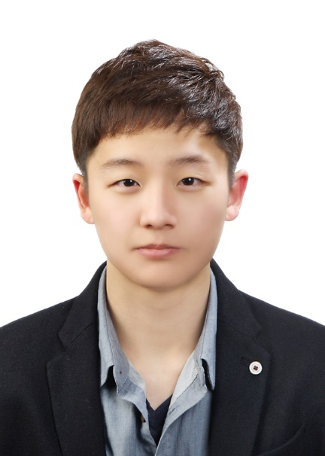
UNDERGRAUDATE INTERNSHIP COM:FORT LAB College of Human Ecology, Seoul National University
1 Gwanak-ro, Gwanak-gu, Seoul
Seoul National University
jhkim9515@snu.ac.kr
010-9418-4018
Education,
Seoul National University, Seoul
Department of Education, Physical Education
MARCH 2015 - PRESENT
Extracurricular Activities
UNDERGRAUDATE INTERNSHIP COM:FORT LAB College of Human Ecology,
Seoul National University
JUNE 2020 - PRESENT

Captain of Handball Varsity Club
Seoul National University
JULY 2017 – FEB 2018

Exchange Student in Netherlands
University of Groningen
JAN 2017 – JULY 2017

