GILYOUNG JANG
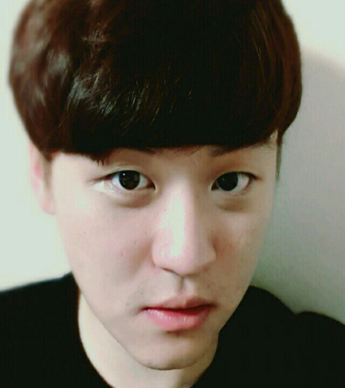
UNDERGRAUDATE INTERNSHIP COM:FORT LAB College of Human Ecology, Seoul National University
1 Gwanak-ro, Gwanak-gu, Seoul
Seoul National University
jgy0421@snu.ac.kr
010-9030-0182
Education,
Seoul National University, Seoul
Department of Education, Physical Education
MARCH 2014 - PRESENT
Extracurricular Activities
UNDERGRAUDATE INTERNSHIP COM:FORT LAB College of Human Ecology,
Seoul National University
JULY 2021 - PRESENT

Captain of SNU Track & Field Team
Jan 2016 – Feb 2017

Internship in Canada
Nov 2014 –Mar 2015

